N:\Riverkeeper\Jerry's Junk\Admin\Logos and graphics-Spokane Riverkeeper\2018.New Logo\2-CMYK-PRINT\HORIZ-RIVERKEEPER.tif

Hangman Creek Water Temperature Report 2018

Jule Schultz

Spokane Riverkeeper

With support from Charlotte Y. Martin Foundation

February, 2019

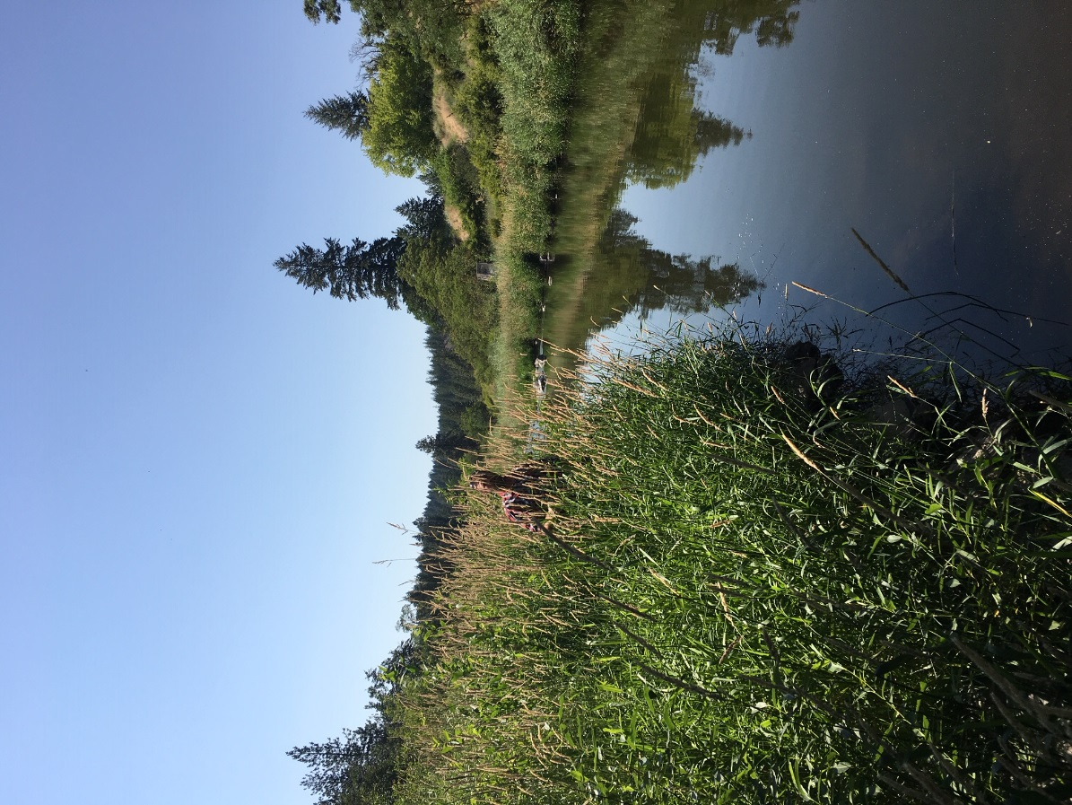

Abstract:

The Spokane Riverkeeper collected water temperature data from the Hangman Creek watershed in 2018. All locations exceeded the state water quality standard of 64.4 F (18 C). Unlike previous years’ data, water temperature in the tributaries were similar to that of the main stem. In addition, water temperatures were lower in the main stem than in previous years. This may be due to the higher water table than in previous years that feeds Hangman Creek and results in higher flows. We compared temperatures in Hangman Creek with daily temperature records, flows, and aquifer height.

Introduction:

Hangman Creek is a small but important tributary of the Spokane River.   Both rivers are in the upper Columbia Basin and a part of the Columbia River Watershed.  The Hangman Creek Watershed spans 695 sq. miles and originates in Idaho (Fig. 1 and 2).  Hangman Creek is highly damaged by erosion, ditching, over-grazing and the removal of riparian habitat by industrial agricultural practices.  Hangman Creek is listed as impaired on the 303(d) list for dissolved oxygen, pH, temperature, fecal coliform, and turbidity.  The designated uses are for interior redband trout rearing, migration, and spawning habitat. The river has a Total Maximum Daily Load (TMDL) for fecal coliform, temperature, and turbidity.  Poor water quality and the damaged watershed have dramatically reduced the presence of Columbia Basin interior redband trout (O. mykiss gairdneri) habitat and populations. Currently, only isolated and fragmented populations exist, and it is unknown to what extent the river is used for migration between the Spokane River and functional spawning habitats in the headwaters.

One effect of this damaged ecosystem is elevated water temperatures.  The State of Washington Water Temperature Standard for non-anadromous interior redband trout is an 18C (64.4F) seven day average of daily maximum temperatures (7DADMax).  Our previous monitoring shows that Hangman Creek fails to meet this standard at most of our sample sites in the watershed.  Many tributaries contain much lower water temperatures and are a potential refuge for redband trout in the watershed.  Fish surveys have found redband trout in the upper watershed on the Coeur d’Alene Tribal Reservation in Idaho, and in a few small tributaries in the lower watershed, such as California and Marshall Creek.   In this study, we investigated whether summer water temperatures meet state standards and which reaches have temperatures cool enough to support the presence of these fish.   The Spokane Riverkeeper placed temperature loggers throughout the Hangman Creek Watershed in summer of 2018 to determine average, maximum, and 7DADM temperatures in Hangman Creek and three tributaries.

Methods:

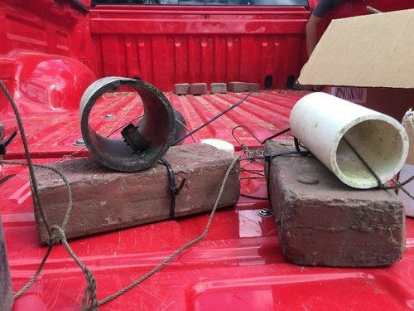

Figure 1. Temperature logger housing for placement in creeks.

We monitored water temperatures in streams using temperature loggers placed in housings in streams throughout the Hangman Watershed.  Onset Hobo Pendant temperature loggers were calibrated by Washington Department of Ecology staff and set to record every 30 minutes.  Loggers were rejected if over 0.3 C discrepancy from actual temperature.  Loggers were placed in a PVC shade and zip tied to a rock or brick to anchor and elevate them above the river bed (fig 2).  At the field location the logger was tied to a piece of twine for retrieval and placed in the creek bed.  The other end of twine was tied to a tree or large boulder.  We placed loggers throughout the watershed, with five in the main-stem of Hangman Creek and three in tributaries (fig 3).  In many locations tributaries go dry in the summer and only streams that were known to flow year round were selected.  Locations of main-stem Hangman Creek loggers were chosen based on accessibility to the Creek. Loggers were placed in Hangman Creek at Waverly, the Tensed (Desmet) bridge over Hangman Creek, the bridge over Bradshaw Road, and at the mouth at Riverside bridge. Loggers were also placed in California Creek Mouth, Marshall Creek, and Rock Creek Mouth. The California Creek logger was found out of the water when retrieved. Data visualization showed that it had been removed on August 9th. Loggers were deployed from July 6th-September 24th.

Boxplot charts were made using extreme daily highs and low temperatures, extreme daily average high and low temperature, average daily temperature for the sampling duration, and seven day average daily maximum temperature (7DADMax).  The 7DADMax was calculated by averaging the maximum daily temperatures over a seven day period and graphing the maximum of this calculation.  Temperature values are displayed as daily maxima in all line charts. Air temperature, flow, and groundwater height data were obtained from the [NWS](https://www.weather.gov/otx/), [USGS](https://waterdata.usgs.gov/usa/nwis/uv?12424000), and [USGS ground water monitoring station](https://waterdata.usgs.gov/nwis/uv?site_no=474011117072901).

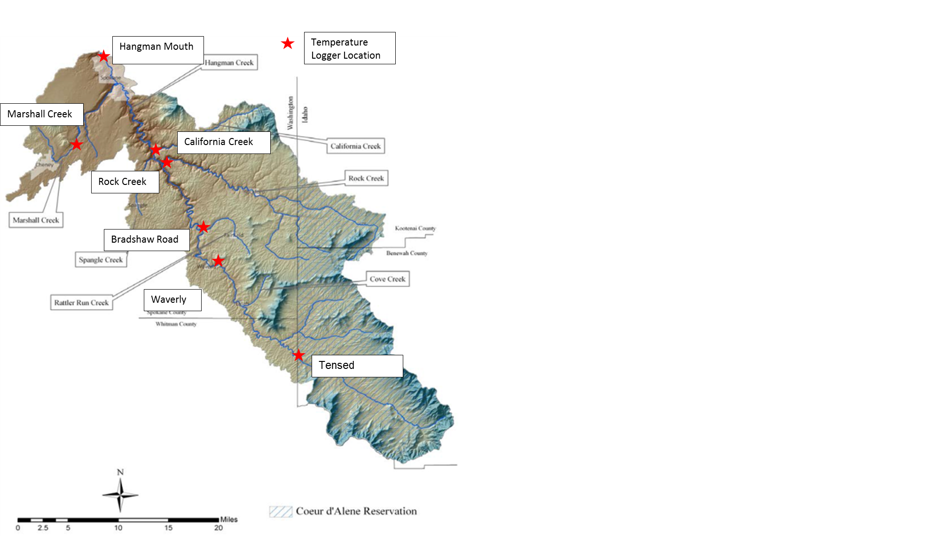

Figure 2. Location of the seven temperature loggers deployed in the Hangman Creek Watershed

Results and Discussion

In 2019, Hangman Creek contained water temperatures in the main stem that were generally cooler than in previous years, while temperatures in the tributaries were warmer. The cooler temperatures were most likely a result of increased flow from groundwater, while the cause of the warmer temperatures in the tributaries is unknown. Even with the cooler water temperatures in the main stem of the Creek, summer temperatures were much higher than the 18 C (64.4 F) state water quality standards set to protect native redband trout.

All locations in the Hangman Creek Watershed in 2018 exceeded state standards for water temperature (Figure 3). Extreme high temperatures ranged from 22-24 C (72-75 F), except for Bradshaw Road (discussed below). High daily averages ranged from 19-21 C (66-69 F). Bradshaw Road had the highest temperature of all locations, with a 7DADMax of 27 C (80 F) and high daily average of 24 C (74 F). California Creek contained the coolest water of all locations measured with a 7DADMax of just over 21 C (70 F) and a high daily overage of 20.5 C (69 F). However, the logger at California Creek was tampered with and a warm period in mid August was not recorded.

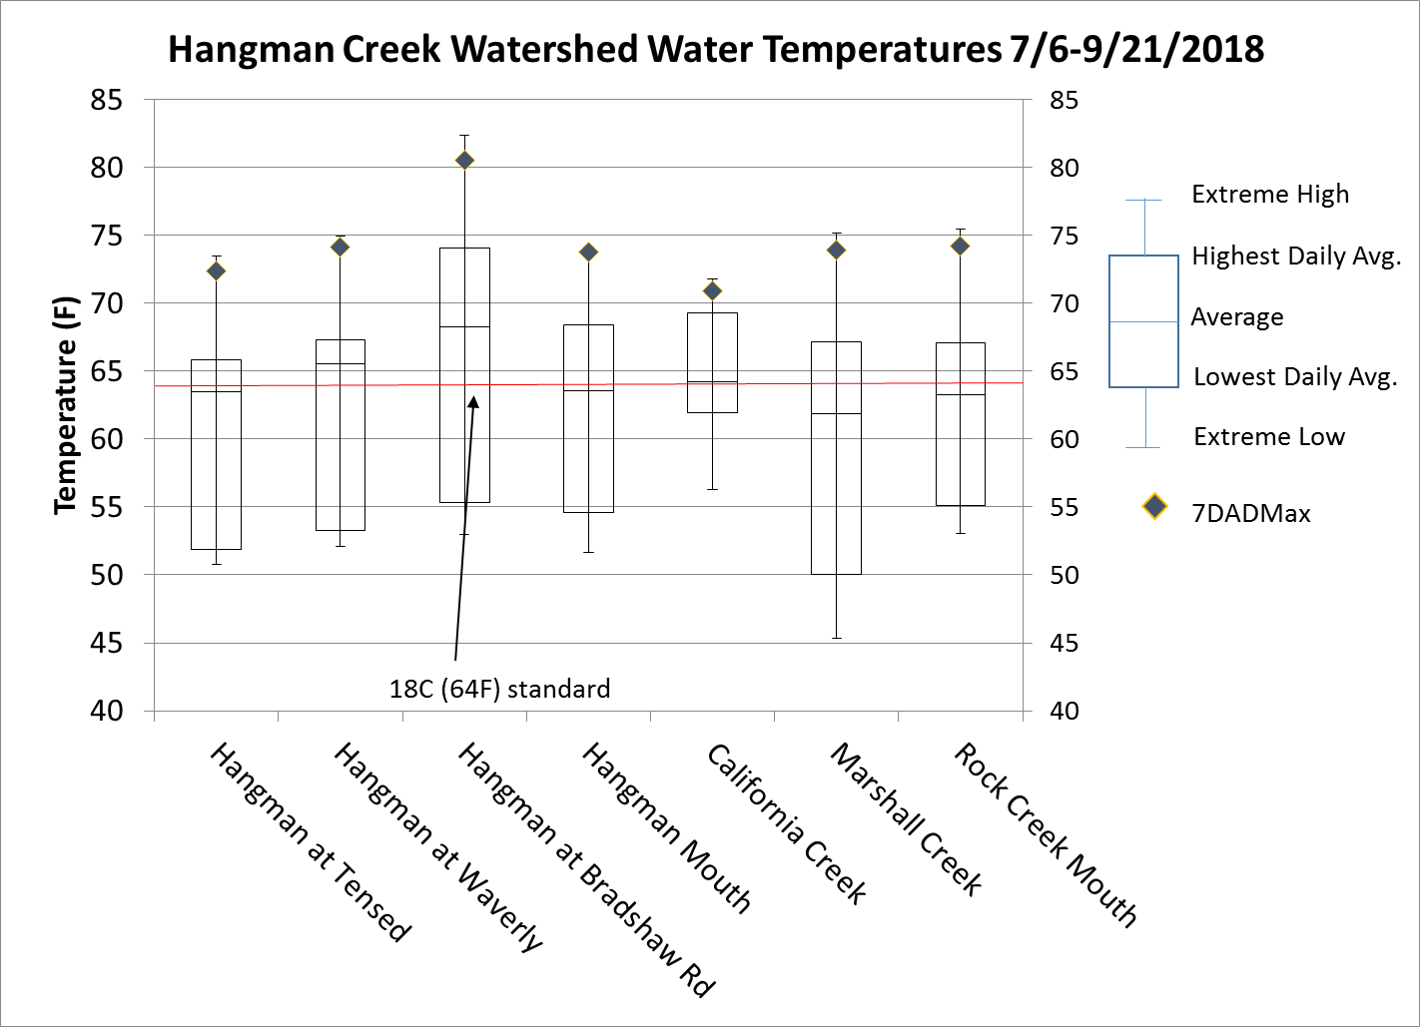

Figure 3. Box plot summaries of water temperature in the Hangman Creek watershed.

In all tributaries’ water temperatures exceeded the 18 C (64.4 F) water temperature standard during the monitoring period (Figure 4). Patterns differed significantly between tributaries though. Rock Creek in early July had the warmest temperatures and then cooled through the summer. This is most likely due to the proportion of cool groundwater to warmer surface water in Rock Creek during these times. As the ratio of warmer surface water in Rock Creek in relation to cooler ground water declines so does the temperature.

California and Marshall Creeks, the two other tributaries monitored, contained water temperatures that were higher than previous years (Table 1). Tributaries in Hangman Creek usually contain the coolest water temperatures in the basin. This is assumed to be because of the contribution of cool groundwater to the tributaries that keep them flowing through the summer (tributaries without summer water flow were not monitored). In 2019 Marshall Creek temperatures reached up to 24 C (75 F) (Figure 4). This is very high for Marshall Creek and exceeds previous year’s temperatures by 1.5-2 C (3-3.5 F) (Table 1). The logger in Marshall Creek was near the water surface when retrieved, due to the low flow in the creek. If water levels fluctuated in the creek, the logger may have been exposed resulting in higher temperatures. However, the logger was underwater when retrieved and showed signs of being submerged (algae growth). July water temperatures in California Creek were higher than previous years as well (Table 1). This logger was originally placed underwater by a few feet and thermal stratification should not have affected it. It is unknown why temperatures in these two tributaries are higher than previous years. Next year’s monitoring should increase the number of tributaries monitored in the Hangman Creek watershed to look at watershed wide patterns in water temperatures.

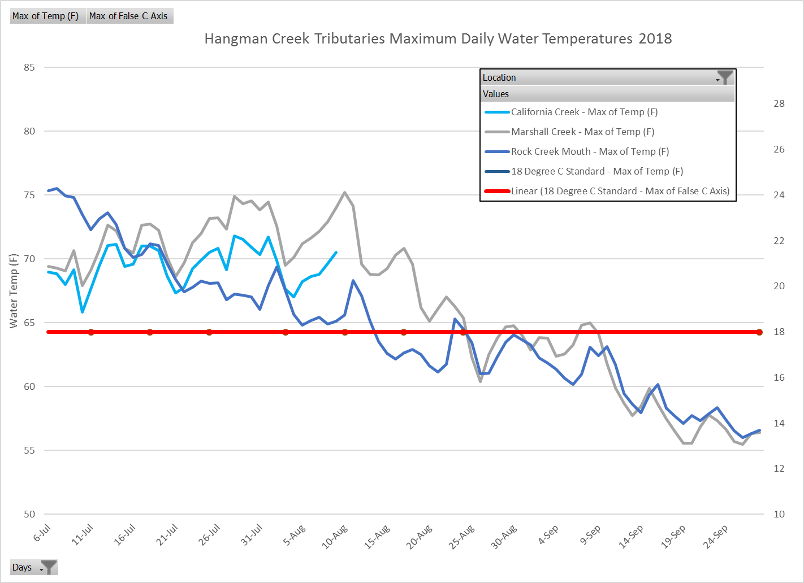

Figure 4. Water temperature in tributaries to Hangman Creek. Data was omitted because the logger in California Creek was tampered with in early August.

In 2018, water temperatures in the main stem of Hangman Creek exceeded the state standard of 18 C (64.4 F), but were much cooler than previous years. Other than Bradshaw Road, water temperatures did not exceed 24 C (75 F) (Figure 5). The coolest location was at Tensed Bridge over Hangman Creek, while water temperatures at Waverly and the mouth were relatively similar (Figure 5). The water temperatures at Waverly show a marked decrease from previous years (Figure 7), with temperatures in 2018 being between 0.5-3 C (~1-5 F) lower than previous years (Table 1).

Although the reason for this isn’t known, we can infer some things from environmental data. Air temperatures in Spokane in July 2018 weren’t cooler than previous years (Figure 13). However, flow in Hangman Creek at the mouth was higher than in 2015 and 2016, but similar to that of 2017 (Figure 9). The flow of Hangman Creek at Tekoa, which is near the headwaters of Hangman Creek, shows higher flows in 2018 than in previous years, especially in August (Figure 10). This contribution is most likely from groundwater, as August rainfall in Spokane was 0.17”, which is not enough to contribute surface water to runoff in creeks. This suggests that increasing flow, probably from groundwater, affects water temperature in the main stem of Hangman Creek.

Water temperatures at Bradshaw Road 2018 showed similar temperatures in previous years (Table 1). Hangman Creek near Bradshaw Road forms a series of pools that are not shaded by riparian vegetation. The Creek is deeper here than in other locations monitored. These slow flowing pools may allow the Creek to heat up.

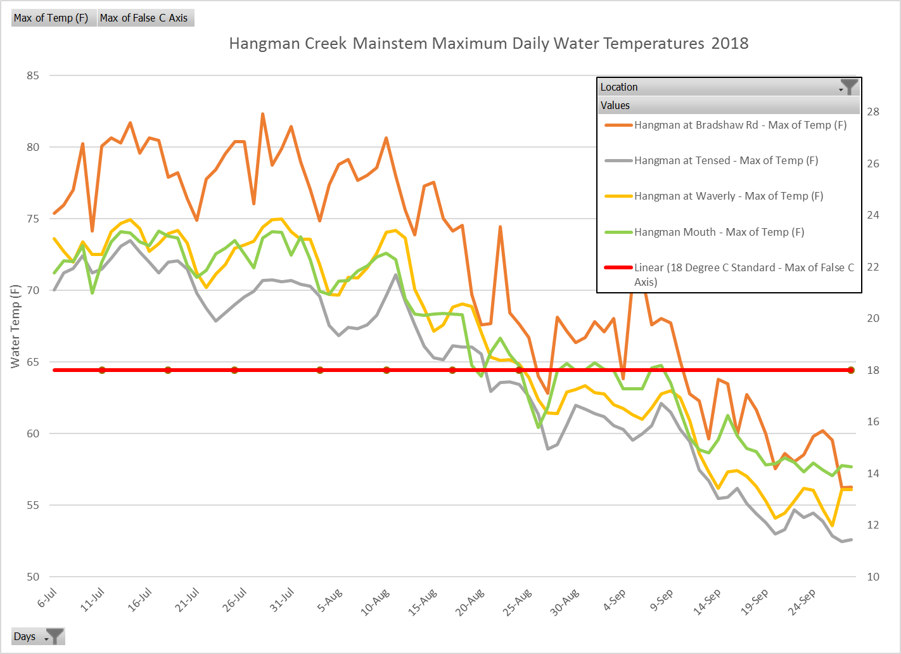

Figure 5. Water temperature in Hangman Creek in summer of 2019. The 18 C (64.4 F) line represents the state water temperature standard.

Water temperature is a limiting factor influencing the spawning and rearing of redband trout, a fish that once inhabited much of Hangman Creek. The 20 C rearing limit was exceeded throughout extent of the monitored area. Water temperature is only one factor influencing the survivorship of redband trout in the Hangman Creek watershed. Our preliminary data lead us to believe high turbidity levels, the result of massive loads of sediment, most likely influence trout populations in the watershed as well. Redband trout are now limited to the upper watershed, in an areas undergoing intense restoration by the Coeur d’Alene Tribe, and California Creek.

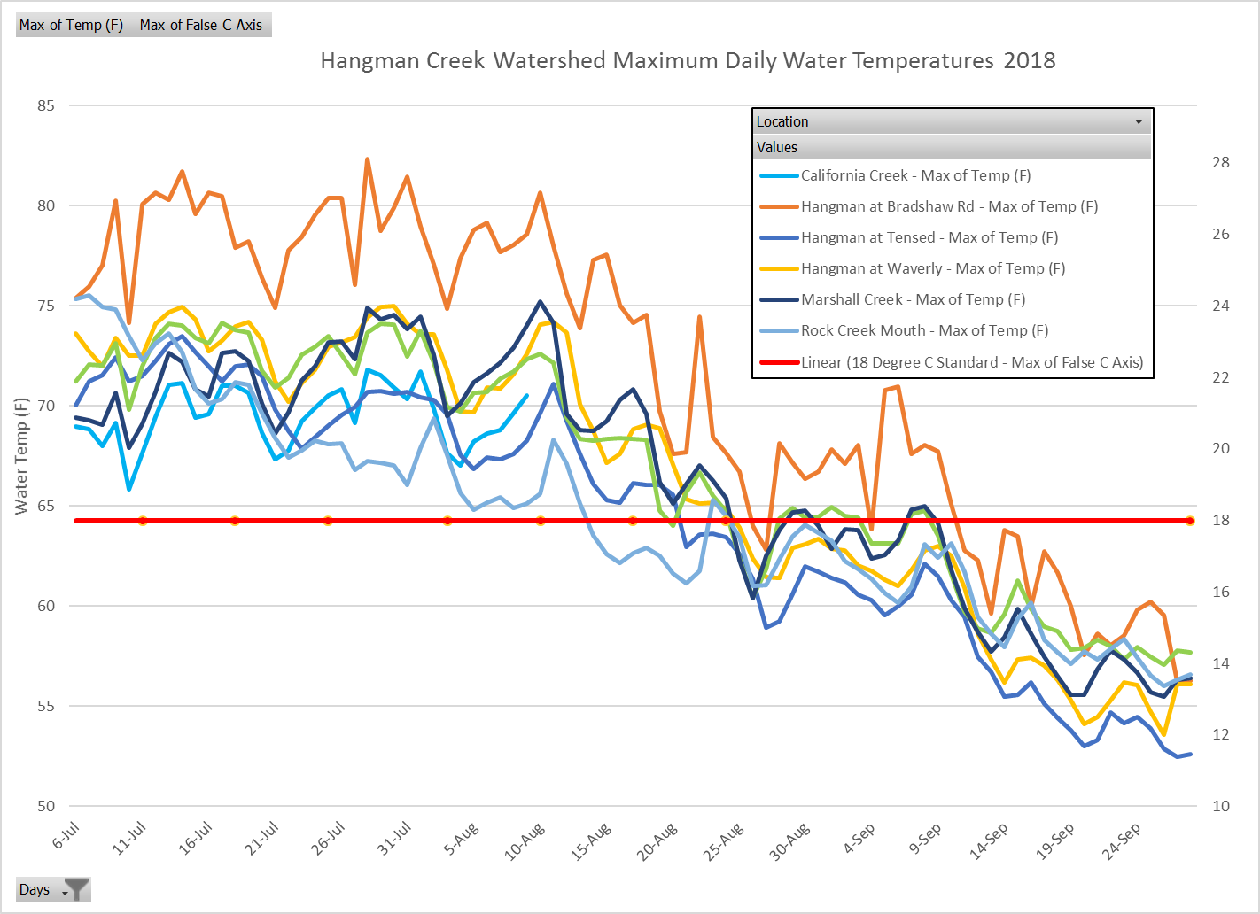

Figure 6. All water temperature sites in the Hangman Creek watershed in summer of 2018. The red line represents the Washington water quality temperature standard of 18 C (64.4 F).

Table 1. Average water temperatures for seven sites in the Hangman Watershed. The main stem of Hangman Creek was cooler than previous years, while Marshall Creek and California Creek saw higher water temperatures than previous years.

|  |  |  |  |  |
| --- | --- | --- | --- | --- |
| **Average of Temp (F)** |  |  |  |  |
| **Row Labels** | **2015** | **2016** | **2017** | **2018** |
| **Hangman at Desmet (Tensed)** |  |  | **68.5** | **66.1** |
| Jul |  |  | 70.7 | 68.1 |
| Aug |  |  | 66.2 | 64.0 |
| **Hangman at Waverly** | **69.8** | **70.0** | **72.3** | **68.2** |
| Jul | 72.2 | 71.3 | 74.8 | 70.0 |
| Aug | 67.8 | 68.8 | 69.9 | 66.5 |
| **Hangman at Bradshaw Rd.** |  | **69.2** | **69.9** | **70.8** |
| Jul |  | 69.8 | 72.3 | 72.7 |
| Aug |  | 68.6 | 67.4 | 69.0 |
| **Hangman Mouth** | **68.9** | **68.0** | **66.0** | **66.5** |
| Jul | 70.8 | 68.6 | 67.9 | 69.2 |
| Aug | 67.4 | 67.4 | 64.1 | 63.8 |
| **Rock Creek Mouth** |  | **61.3** | **66.9** | **66.0** |
| Jul |  | 62.2 | 70.0 | 69.4 |
| Aug |  | 60.3 | 63.9 | 62.6 |
| **California Creek** | **62.6** |  | **63.2** | **65.7** |
| Jul | 64.3 |  | 64.7 | 66.1 |
| Aug | 61.2 |  | 61.7 | 64.0 |
| **Marshall Creek** |  | **61.1** | **62.0** | **65.3** |
| Jul |  | 62.0 | 63.4 | 67.0 |
| Aug |  | 60.2 | 60.6 | 63.5 |

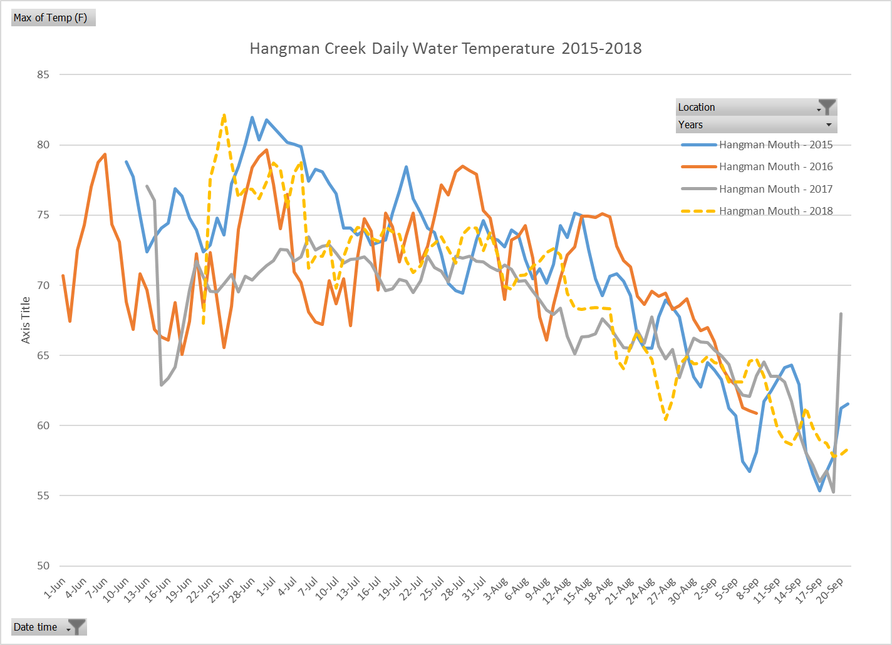

Figure 7. Water temperatures at the mouth of Hangman Creek from 2015-2018. 2018 had cooler than average water temperatures.

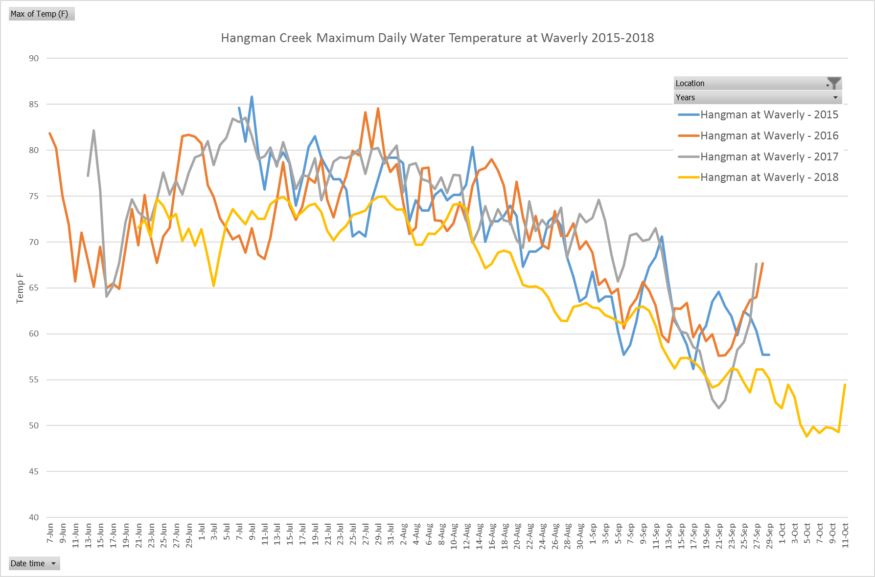

Figure 8. Water temperatures in Hangman Creek at Roberts Rd. in Waverly from 2015-2018. 2018 had cooler than average water temperatures.

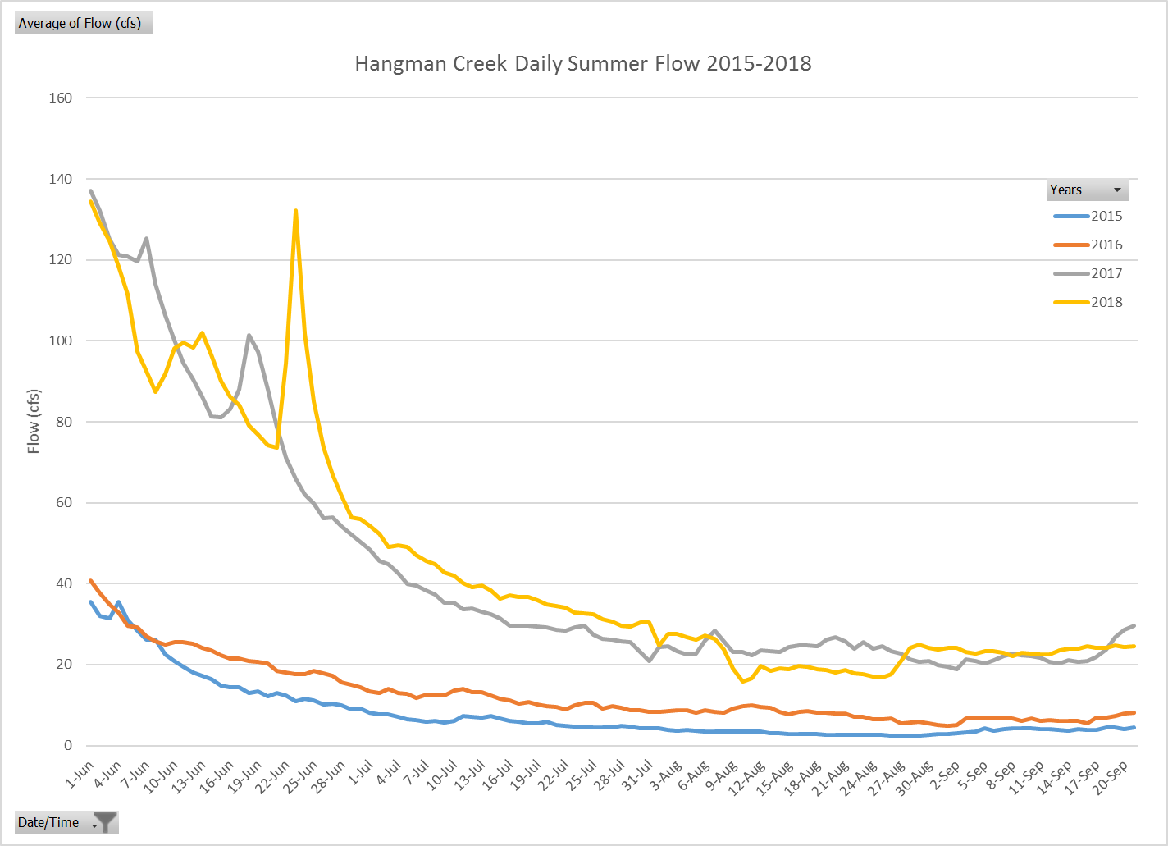

Figure 9. Hangman Creek flow at the mouth in summers of 2015-2018. Flow in 2017 and 2018 were much greater than in 2015 and 2016.

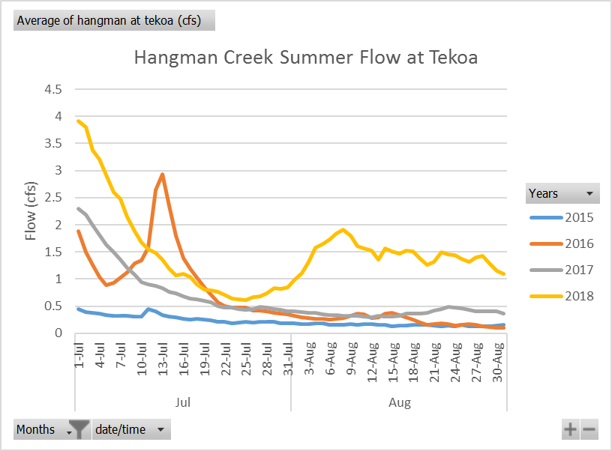

Figure 10. Summer flow of Hangman Creek at Tekoa was higher than in previous years, suggesting groundwater could have decreased water temperatures.

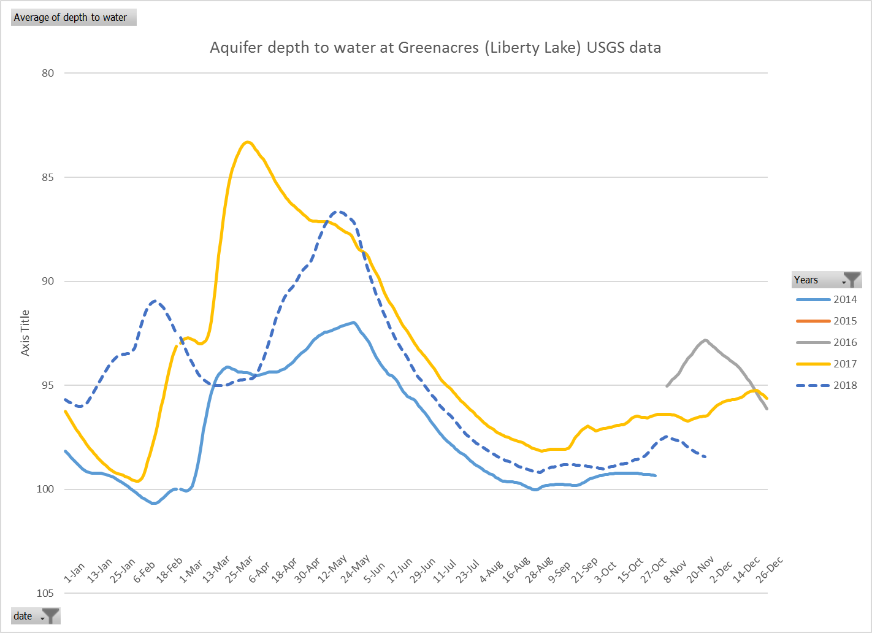

Figure 11. Aquifer depth in Liberty Lake in 2014, 2017, and 2018 shows the possible groundwater in the Hangman Creek system (although not in the Hangman Basin, high groundwater levels in Liberty Lake suggest high groundwater in nearby Hangman Creek watershed).

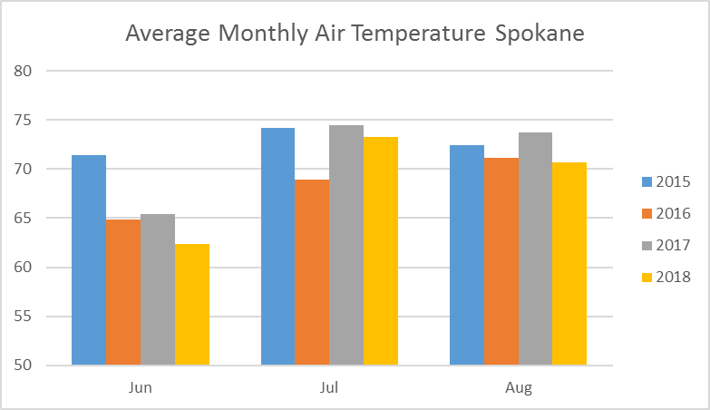

Figure 12. Average monthly temperatures in Spokane from 2015-2018. 2018 had a cool June, an average July and August. Data from National Weather Service Spokane.